Assignment 01

Food Ordering System - Database Design

# Question No. 01

# Context Level Data Flow Diagram (DFD - Level 0)

The Context-Level Data Flow Diagram (DFD) shows the system as a single process interacting with external entities.

**Entities:**

Customer  
 Restaurant  
 Payment Gateway

**Main System:**  
 Online Food Ordering System

**Data Flows:**

* Customer → Browse Menus, Add to Cart, Place Order → System
* System → Show Menus, Order Confirmation → Customer
* Restaurant → Send Menu Items, Receive Orders → System
* System → Forward Orders → Restaurant
* System → Send Payment Info → Payment Gateway
* Payment Gateway → Payment Confirmation → System

Diagram:

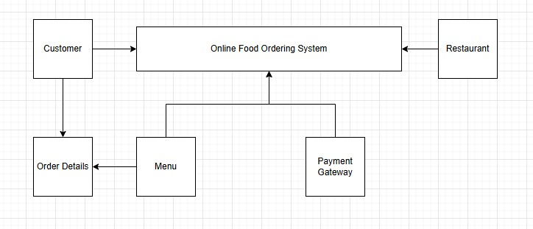

# Question No. 02

# ERD (Entity-Relationship Diagram)

## Entities and Attributes

**Customer:**

* - CustomerID (PK)
* - Name
* - Email
* - PhoneNumber
* - DeliveryAddress

**Restaurant:**

* - RestaurantID (PK)
* - Name
* - ContactInfo
* - Location

**MenuItem:**

* - MenuItemID (PK)
* - RestaurantID (FK)
* - Name
* - Price
* - Description
* - AvailabilityStatus

**ShoppingCart:**

* - CartID (PK)
* - CustomerID (FK)
* - CreatedDate

**CartItem:**

* - CartItemID (PK)
* - CartID (FK)
* - MenuItemID (FK)
* - Quantity

**Order:**

* - OrderID (PK)
* - CustomerID (FK)
* - OrderDate
* - TotalAmount

**OrderDetail:**

* - OrderDetailID (PK)
* - OrderID (FK)
* - MenuItemID (FK)
* - Quantity
* - PriceAtPurchase

**Payment:**

* - PaymentID (PK)
* - OrderID (FK)
* - PaymentDate
* - Amount
* - PaymentMethod
* - PaymentStatus

## Entity Relationships

* Customer ↔ Order → One-to-Many (A customer can place many orders)
* Customer ↔ ShoppingCart → One-to-One or One-to-Many (depending on implementation)
* Restaurant ↔ MenuItem → One-to-Many (A restaurant can offer many menu items)
* Order ↔ OrderDetail → One-to-Many (An order has many order details)
* MenuItem ↔ OrderDetail → Many-to-Many via OrderDetail
* ShoppingCart ↔ CartItem → One-to-Many
* CartItem ↔ MenuItem → Many-to-One
* Order ↔ Payment → One-to-One

## ERD Structure

